**How to install an SSL Certificate in cPanel**

In this short article, we will cover how to install an **SSL Certificate** in cPanel.

If you haven’t already, make sure to read our previous article on [generating a **CSR request**](https://chemicloud.com/kb/article/generate-csr-cpanel/). **The CSR is necessary in order to obtain your SSL Certificate.**

**What is SSL?**

First, let’s look at what **SSL** stands for. It is the abbreviation for **Secure Sockets Layer**. This is actually a piece of code which enables a web server hosting your website to communicate securely with any web client or browser on the internet. SSL certificates guarantee that the traffic between server and client is secured through the power of encryption.

Whether you’re dealing with sensitive customer data (like payment details) or simply run an online store, it is generally a good practice to purchase an SSL Certificate. This will increase your site’s search engine rankings, boost customer trust and in turn increase potential sales. Another additional benefit is that SSL certificates help prevent data theft when dealing with sensitive information.

**How to Install an SSL Certificate in cPanel**

**1.** The first step is to [Log-in](https://chemicloud.com/kb/article/how-to-login-cpanel-whm/) to your **cPanel** account >> go to the **Security section** >> click on **SSL/TLS** >> then **Install and Manage SSL for your site (HTTPS)**.

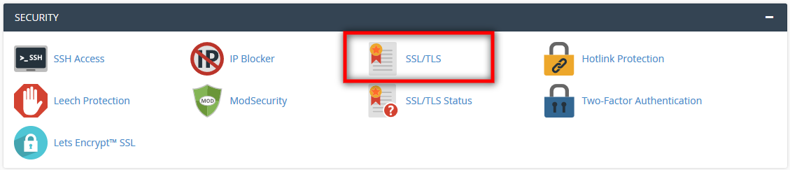

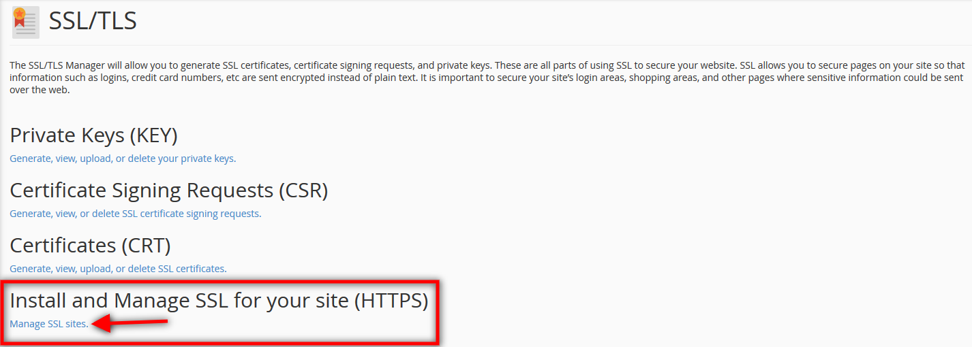

**2.** Secondly, copy and paste the code you received from your **Certificate Authority** into the **Certificate (CRT)**text box. Make sure to include the *—–BEGIN CERTIFICATE—–* header and *—–END CERTIFICATE—–* footer. The Certificate Authority is the company or provider from whom you requested/purchased the SSL certificate.

**3.** Next, click on the **Autofill by Certificate**button and the system will attempt to fetch the domain name and associated private key. You can also do this manually, by selecting your domain from the drop-down menu and fill in the boxes accordingly.

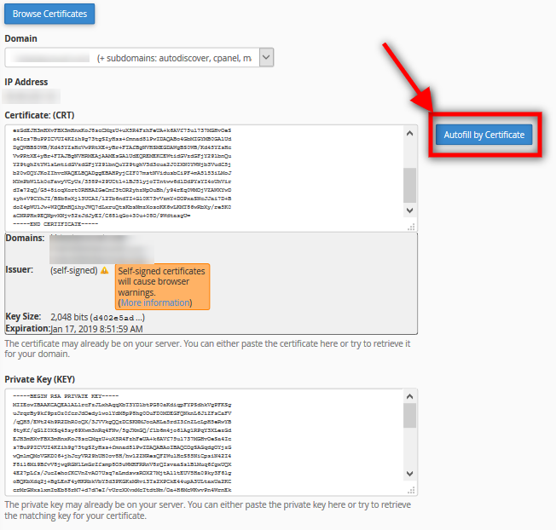

**4.** If it hasn’t already been filled in automatically, copy and paste the information provided by the Certificate Authority into the according to text box (**CA-BUNDLE**).

**5.** Finally, click on **Install Certificate**and cPanel will install your SSL Certificate onto the server.ww

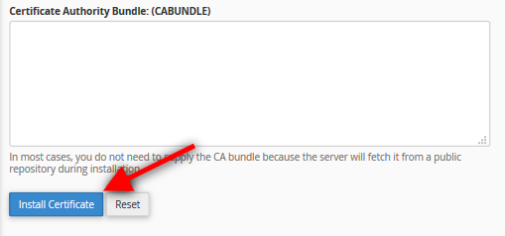

**Congratulations! This wasn’t so difficult now, was it?! We are here if you have any questions or feedback about this topic.**